# **Requirements for the sharetribe platform “coworkingspaces”**

**First part of landing page:**

1. **Topbar:**
   1. Background color: White
   2. Fonts color: Black
   3. Layout: same as the flex template
2. **Search area:**
   1. Standard like the flex template, but no nominated location !!
3. **Main title**
   1. Location: above the picture
   2. Title: “Book and discover coworkingspaces”
   3. Font color: Black
   4. Background color “White”
4. **Second title:**
   1. Location: Inside of the picture
   2. Font color: white
   3. Text: “The easiest way to book a coworkingspace everwhere”
5. **Button:**
   1. Background color: white
   2. Text color: black
   3. Text: “Try it now”
6. **Background picture**
   1. Default picture in the flex template, we can change it later

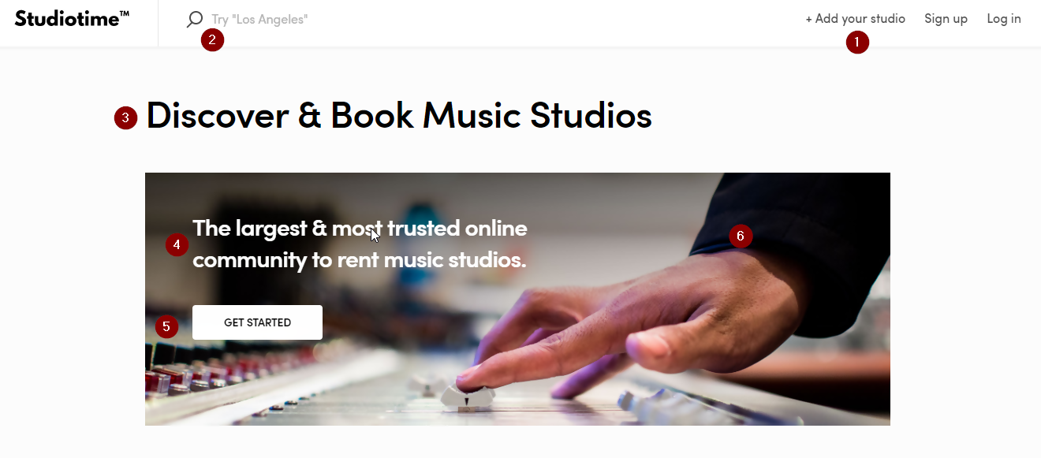

**Second part of landing page:**

1. **Title:**
   1. Font color: Black
   2. Title: “Discover a coworkingspace”
   3. Subtitle: “Find and book a coworkingspace nearby”
2. **Citys:**
   1. 3 different pictures
   2. City name also in white and in the middle of the picture like the example
3. **Link:**
   1. At the End Link “explore another coworkingspaces nearby”

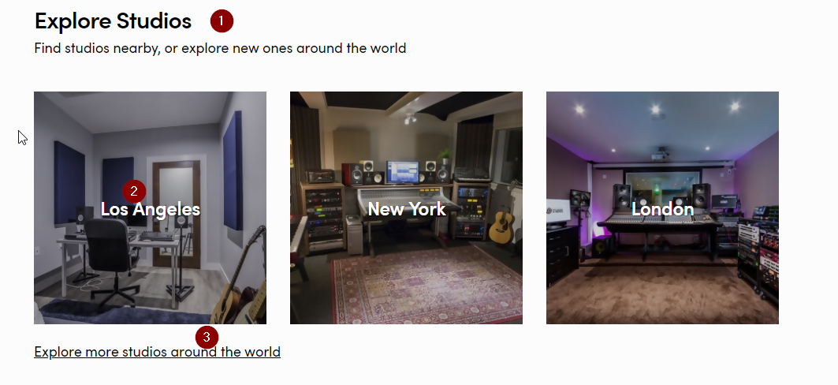

1. **Find your premium coworkingspace now:**
   1. List 9 premium spaces alternating by every page load
   2. Implement the premium tag in front of the description

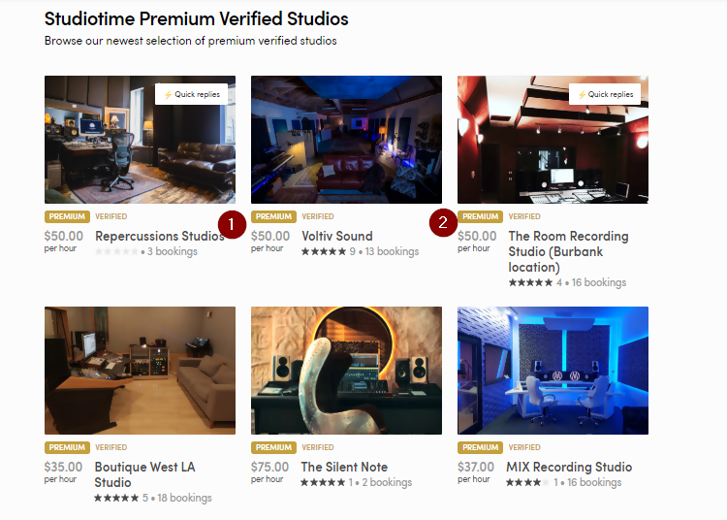

1. **At the end a link “See all premium Studios”**
2. **At the End there is the top main area with some basic descriptions from the booking are, there are 3 categories:**
   1. **Meeting rooms**
   2. **Open plan office**
   3. **Single office**
   4. **Event locations**

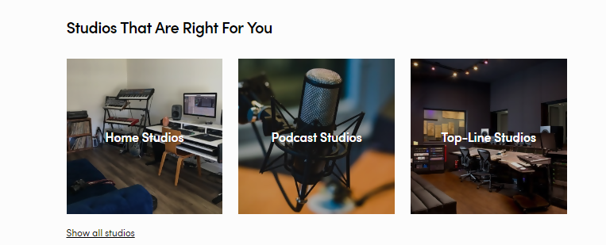

**At the end there is the area “How coworkingspaces works”**

* **This are is in the template split in 3 different areas. I want to implement there only one picture with the rules and “how it works” on it 🡪 Like the example below!**

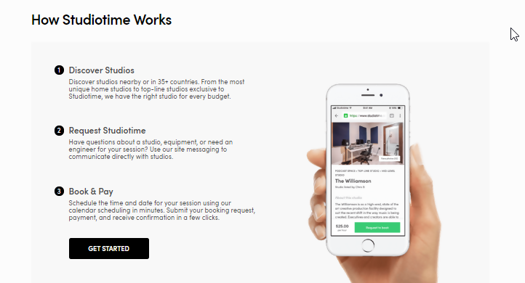

At the end, there is the menue for the different pages. The only link which is not standard is the one for the “Increase your coworkingspace turnover now”

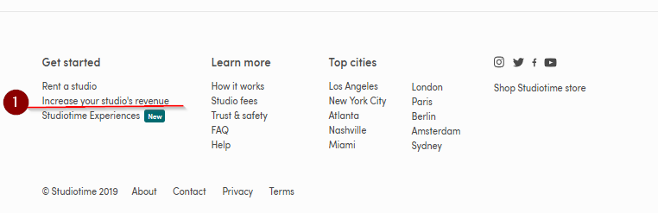

All others we can use from the standard template, which is delivered from sharetribe flex

On this page, there are only the option “Monthly billing”, but there are also 2 different plans with the same marketing terms like studiotime.io ( the additional ones I can change by myself, later)

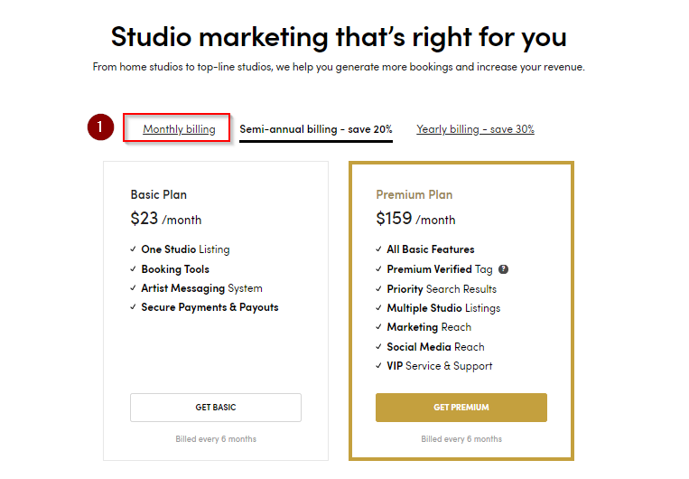

The other pages I can adjust by myself, but important is that you can configure the mapbox and also the booking process with stripe, cause Im not able to do that.

In the payment process there is a fee for every booking, on both site. The customer and also the provider will pay 10% fee. Please set up this process like this.